Bandit Security Analysis Report
Python Static Security Analysis
Project: ghostnet-backend
Date: May 4, 2026 | Run Time: 21:40:59 UTC

1. Executive Summary
This report presents the results of a static security analysis performed on the ghostnet-backend Python codebase using Bandit, the industry-standard Python security linting tool. The analysis was conducted across all Python source files in the project. No security issues were detected in either scan run.
Overall Security Status | PASSED — No Issues Identified
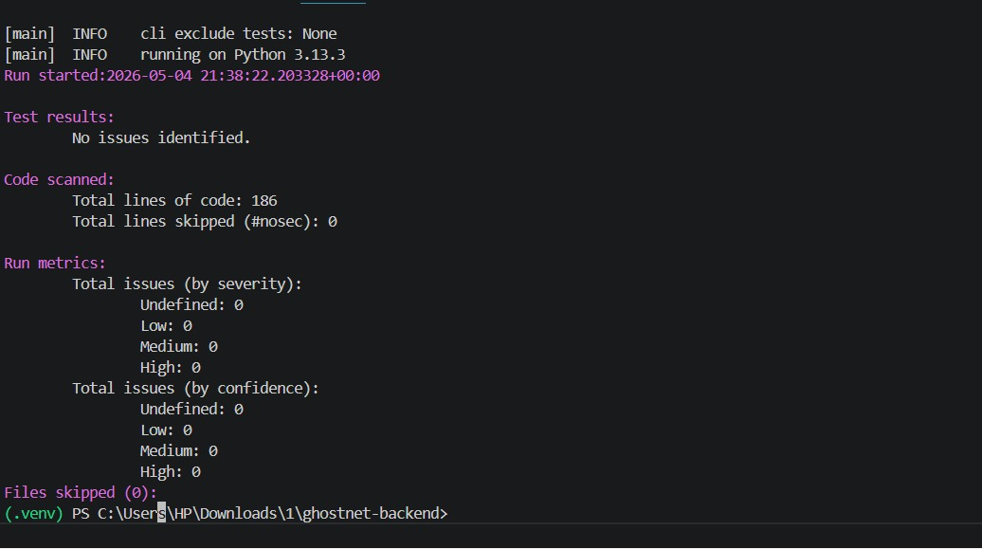

2. Scan Configuration
Parameter | Value
Tool | Bandit (Python Security Linter)
Python Version | Python 3.13.3
Project | ghostnet-backend
Run 1 Timestamp | 2026-05-04 21:38:22 UTC
Run 2 Timestamp | 2026-05-04 21:40:59 UTC
CLI Exclusions | None
Nosec Skips | 0

3. Code Metrics
Metric | Count
Total Lines of Code | 186
Lines Skipped (#nosec) | 0
Issues Disabled (e.g. #nosec BXXX) | 0
Files Scanned | All project files
Files Skipped | 0

4. Issue Summary

4.1 Issues by Severity
Severity Level | Issue Count | Status
Undefined | 0 | CLEAR
Low | 0 | CLEAR
Medium | 0 | CLEAR
High | 0 | CLEAR

4.2 Issues by Confidence
Confidence Level | Issue Count | Status
Undefined | 0 | CLEAR
Low | 0 | CLEAR
Medium | 0 | CLEAR
High | 0 | CLEAR

5. Detailed Findings
No security vulnerabilities, weaknesses, or potential issues were identified during this analysis. All code scanned passed Bandit's security checks without exception.

6. Conclusion & Recommendations
The ghostnet-backend codebase has successfully passed Bandit static security analysis with zero issues identified across two consecutive scan runs. This indicates that the current codebase does not contain common Python security anti-patterns detectable by Bandit.
Recommended next steps:
1. Integrate Bandit into your CI/CD pipeline to run on every pull request.
2. Schedule regular periodic scans as the codebase grows.
3. Complement Bandit with dependency vulnerability scanning (e.g., pip-audit or Safety).
4. Consider adding SAST tools for broader coverage beyond Python-specific checks.

Generated by Bandit Security Analysis | ghostnet-backend | May 4, 2026

